**CS2111 Final Project Summary**

**INSTRUCTIONS:** Type out your answer directly below each question. If a question does not apply to your project, type in N/A. When finished, save this file as a PDF and upload it to the Blackboard.

**BASICS**

**Your group members?**

Shumokh Abdullah-S21107192

Lulu Abdullah- S20206893

Ghaya krimly- S20106770

**What is the topic of your final project?**

Online Makeup Store

**Who is the intended audience?**

Women, aged 18 and above

**Provide a brief summary of the functionalities of your project.**

The website starts by offering the choice to the user to several things:

1- Learn more about the website

3- Add products to the cart to purchase it

4- Send a message to the website owner

5-Admin login

6- ONLY admin can delete a product

7- ONLY admin can change the price of a product.

**FRONT-END**

**What is the total page count?**

6 pages

**List the names of any external stylesheet used in this project below.**

style.css

**List any CSS libraries/frameworks used in this project (e.g. Bootstrap) below.**

Bootstrap

**List any JavaScript libraries/frameworks used in this project below.**

Sweetalert

**How does your project meet the Interactivity requirement?**

1-All designs display correctly in different screens with no errors, and all links take users somewhere

2-Navbar with logo on left

3-Javascript user inputs validation

4- JavaScript, event handler, to display helpful hints about form inputs when the user onfocus.

5-php handles a user input error

6- Used MySQLi to interact with database

**BACK-END**

**Attach a screenshot of the final database diagram (just the diagram, do not include any records) below.**

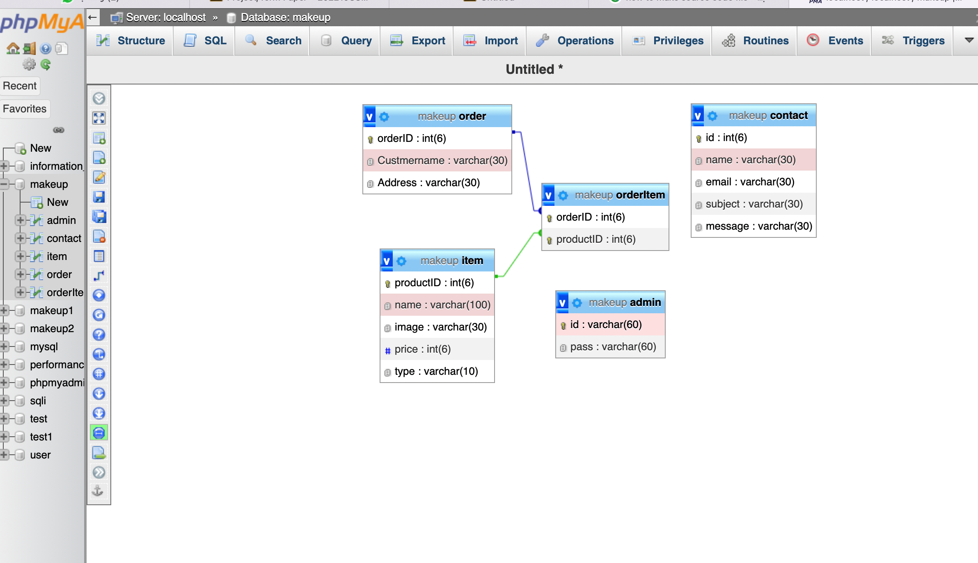

**Where in your project do you insert a record to the database (the ‘C’ in CRUD)?**

1. **In contact.php page:**

Insert into contact table the contact records

1. **In cart.php page:**

Insert into order table and orderitem table the order records

**Where in your project do you search and display record(s) from the database (the ‘R’ in CRUD)?**

1. **In product.php page:**

Display all products from item table

1. **In cart.php page:**

Display the product chosen by the user

**Where in your project do you update and existing record(s) the database (the ‘U’ in CRUD)?**

1. **In change_price.php:**

The admin can update the product price

**Where in your project do you delete existing record(s) from the database (the ‘D’ in CRUD)?**

1. **In delete_products.php:**

The admin can delete product from item table

**MISC**

**If your project requires any admin credentials (i.e. only admin users can access a certain page), list the credentials below.**

Only admin can display all the records in order table

Only admin can delete a product from item table

Only admin can update the price pf products in item table

**Provide any other information that you think the grader/instructor should know when grading your final project below.**

N/A

**Screenshots**

**Home page**





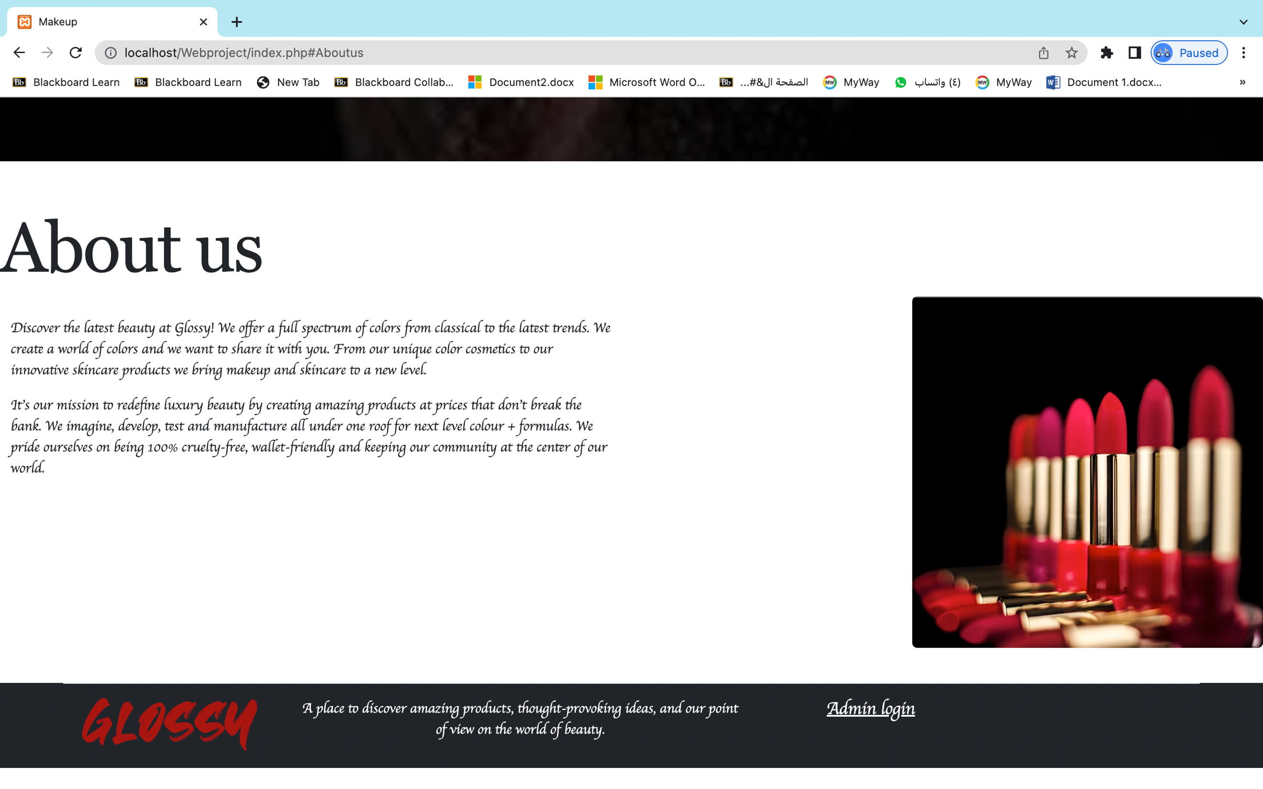

Product page 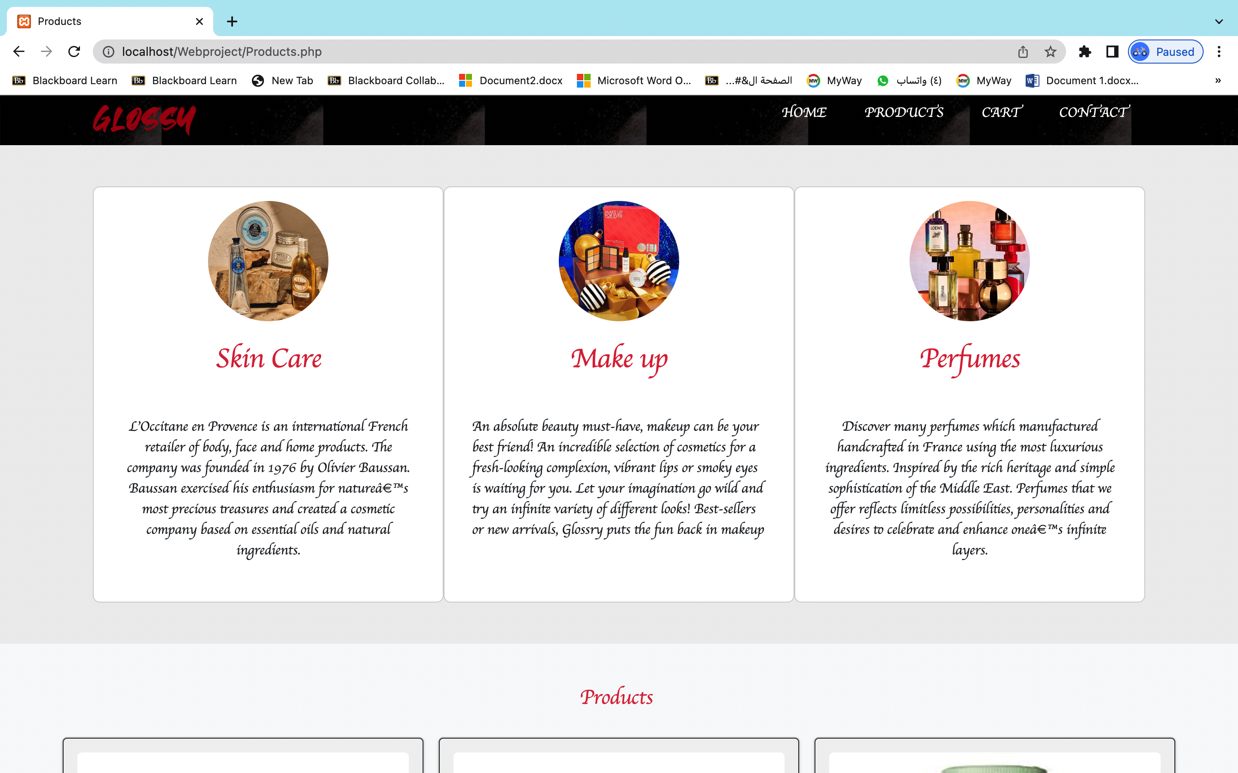

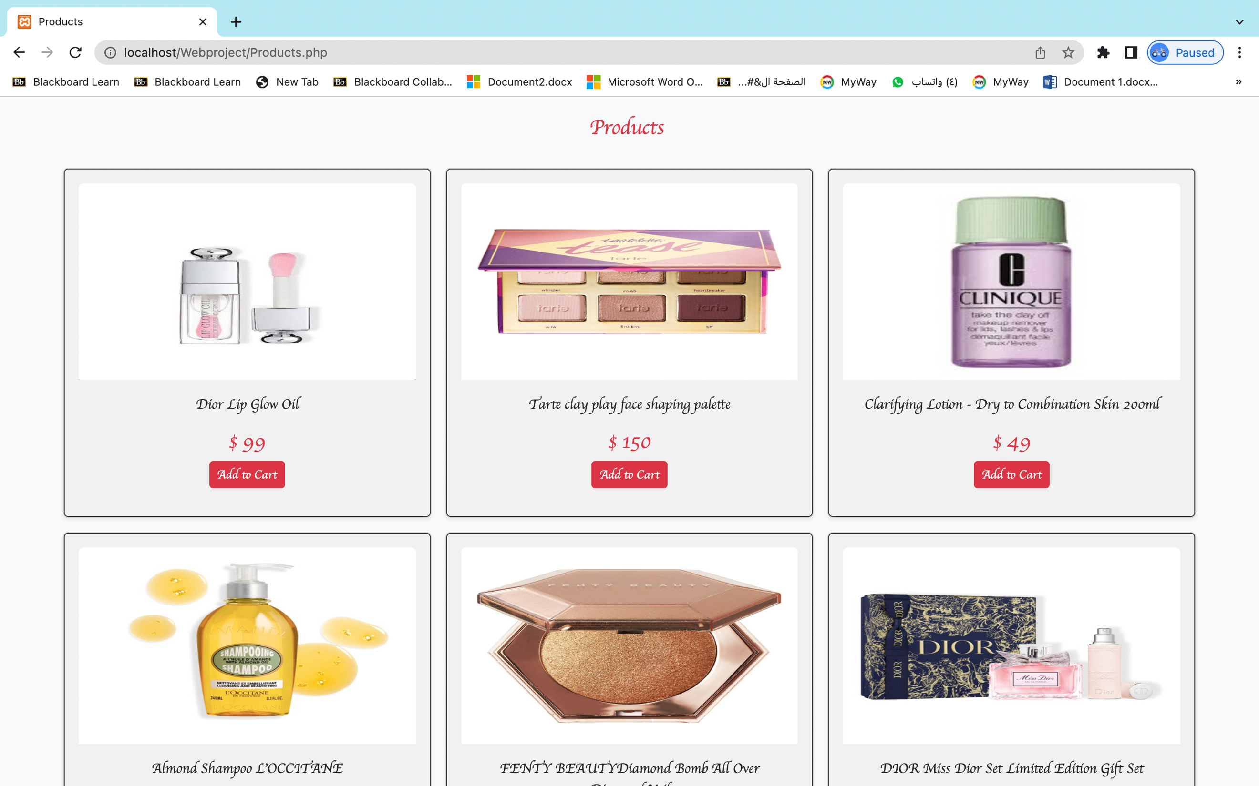

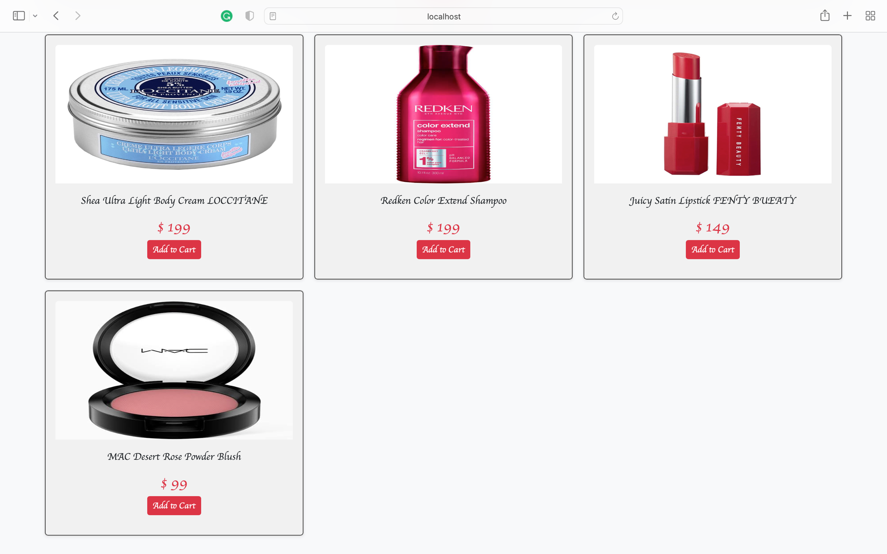

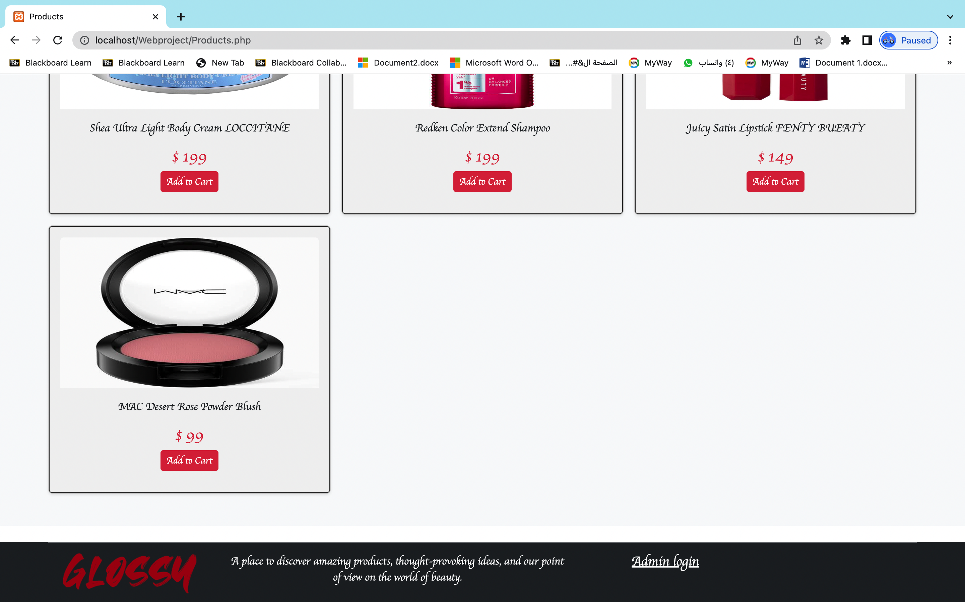

Cart page

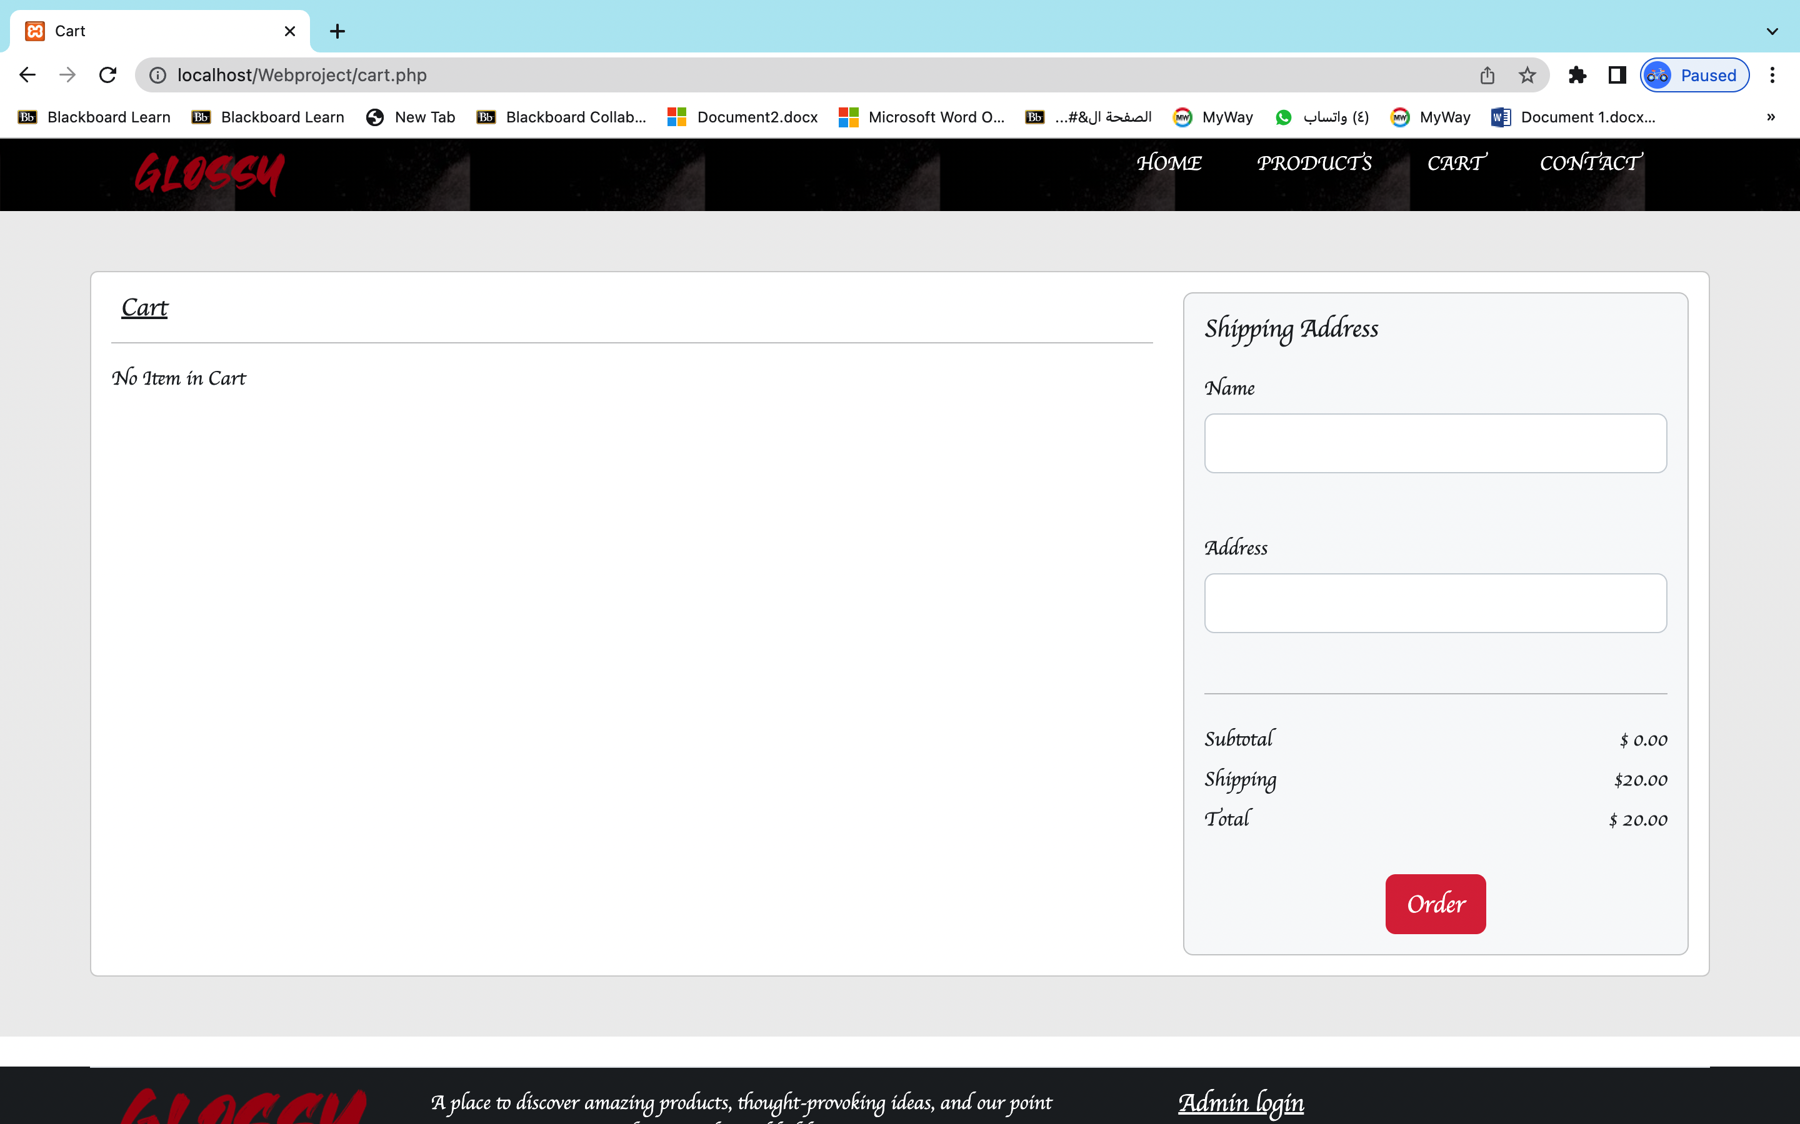

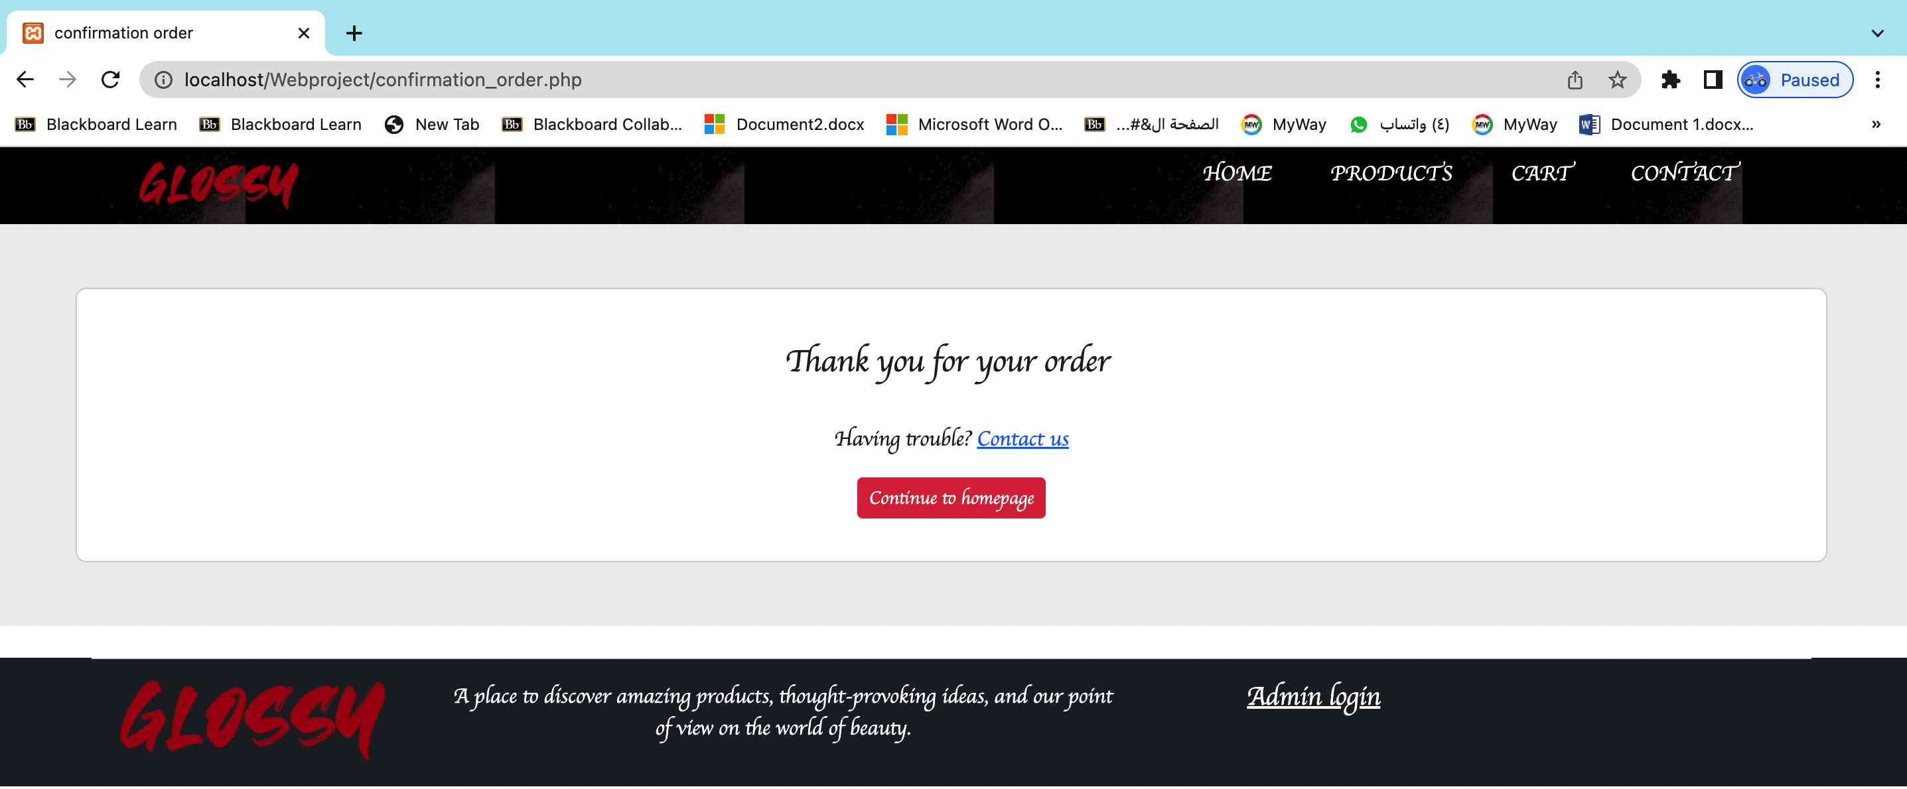

Contact page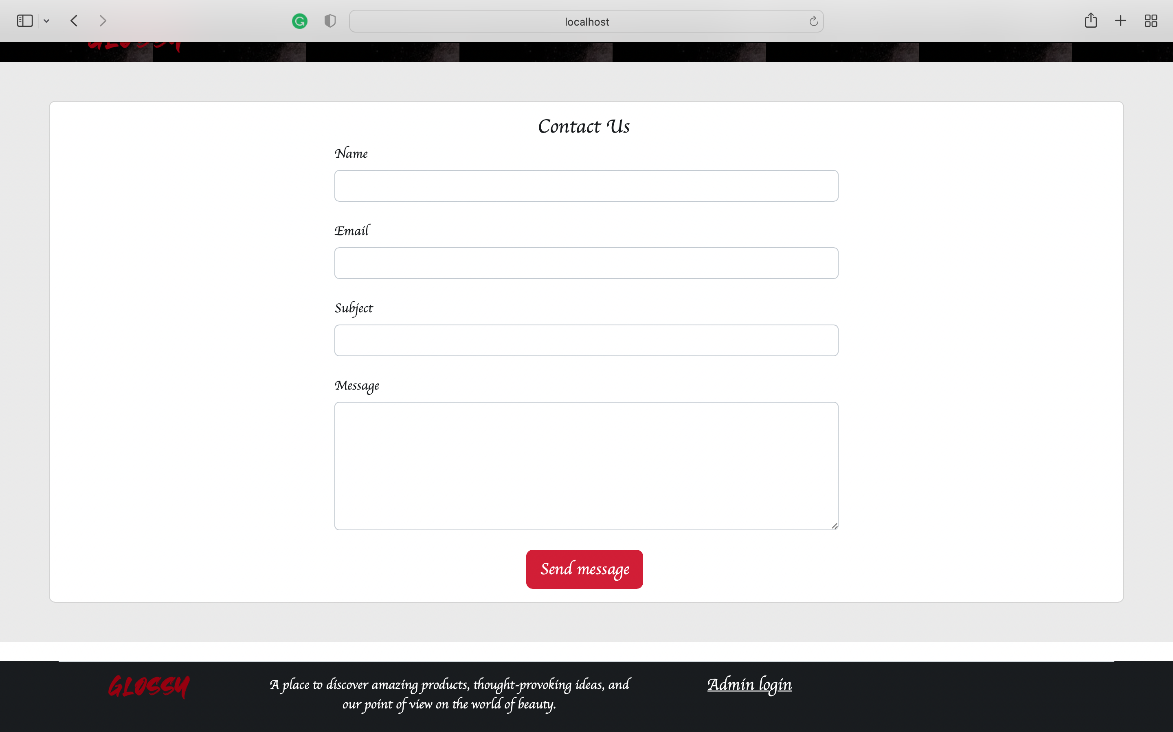

Admin login page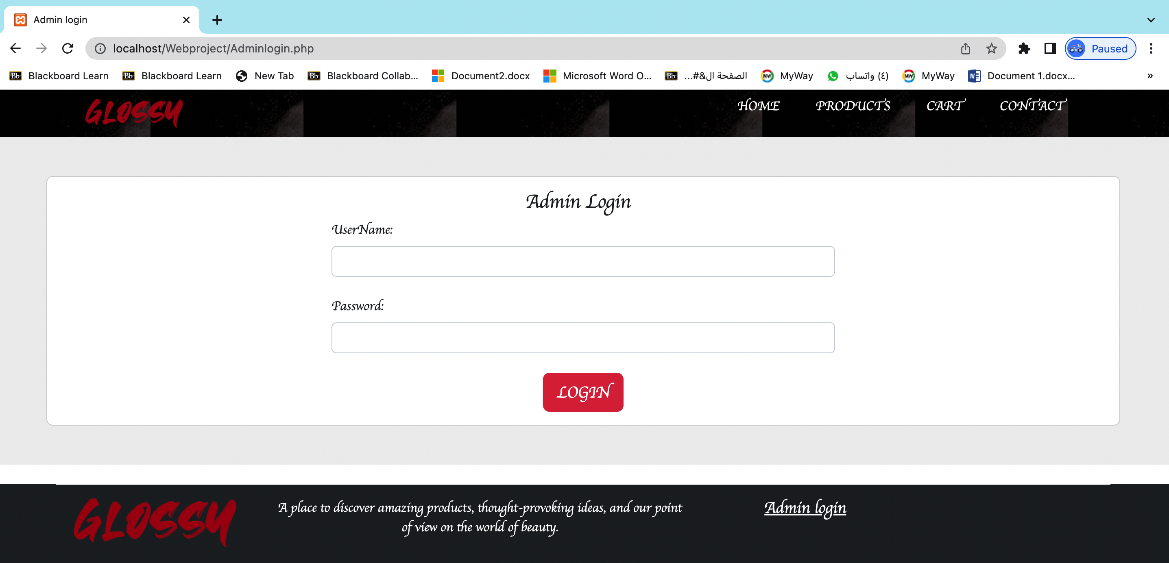

Admin page